What’s the Blu-ray Disc?

Why was the Blu-ray Disc created?
Today’s high-definition video equipment has made it easy to enjoy HD broadcasts and other high-quality content at home. As the content increases in image and sound quality, though, the media for recording and playing it also has to offer larger data capacity and higher speed.
The Blu-ray Disc (BD) is a new-generation optical disc media that responds to these needs.
The Blu-ray Disc is a de facto global standard that is being developed and promoted by a total of 173 companies (as of June 22, 2006) around the world. These include leading electronics companies such as Hitachi, Pioneer, Sony and Sharp, and film studios such as Walt Disney Pictures, Sony Pictures Entertainment, 20th Century Fox and Warner Brothers Entertainment.

What does the high storage capacity of the Blu-ray Disc offer to users?
With its 12-cm diameter, the Blu-ray Disc does not look any different from a DVD disc. There’s a major difference, however, in its storage capacity. The Blu-ray Disc is able to store 50 GB (single-side, double-layer disc) of data, as compared to the 4.7 GB (gigabytes) of the DVD disc. This is enough to record more than four hours of high-definition video with 7.1-channel surround sound onto a single disc..

Basic Blu-ray Technologies

The Incredible Data Capacity of the Blu-ray Disc
The Blu-ray Disc is an optical disc format that was created to meet the needs of high-definition video by storing a huge amount of data.
The Blu-ray Disc has the same dimensions as CD and DVD discs, with a 12-cm diameter, but...
...it features an amazing data storage capacity.
While a DVD disc stores up to 4.7 GB (gigabytes) of data on one side, the Blu-ray Disc can hold as much as 25 GB on a single side, giving it more than five times the storage capacity.
Because each recording layer of a single-side, dual-layer Blu-ray Disc is capable of storing 25 GB of data, the total capacity is an astonishing 50 GB per disc. In other words, one Blu-ray Disc can store as much data as ten DVD discs.
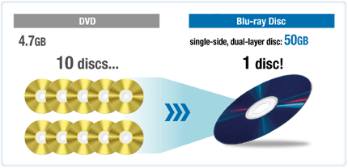
How does the Blu-ray Disc achieve such a large data storage capacity?
Key Technologies for Efficient Use of Limited Space
The Blu-ray Disc is 12 cm in diameter.
To efficiently record a large amount of data in a disc having the same dimensions as CD and DVD discs, it was necessary to develop different technologies from those used in CDs and DVDs.
There are three key points in these technologies.
Blue* laser
*While the Blu-ray laser is also known as a blue-violet laser, we simply call it a blue laser here.
Objective lens with a large numerical aperture (NA)
0.1-mm transparent protective layer (cover layer)
We use a laser beam to read and write information from and to the Blu-ray Disc, but the wavelength of the Blu-ray Disc is different from those that we use for CD and DVD discs.
These are enlarged views of disc recording surfaces. Can you tell which photo shows which disc surface?

Track pitch: 0.32 mm Capacity: 25GB
As viewed from left to right, the photos show a Blu-ray Disc, a DVD disc and a CD disc. The sections that appear black in these photos are pits where information is recorded. A comparison of these photos shows that the pits, and the intervals between them, are smaller and denser on the Blu-ray Disc. This allows the Blu-ray Disc to store data at a higher density.
While the track pitch for recording signals is 0.74 µm (micrometers) on the DVD disc, it is a narrower 0.32 µm on the Blu-ray Disc. One micrometer equals 1/1,000 of a millimeter. Given that the average thickness of a strand of hair is about 0.1 mm, or 100 µm, more than 300 tracks can fit into the width of a single strand of hair on the Blu-ray Disc. As these figures indicate, the Blu-ray Disc stores a huge amount of data in a very small area.
The blue, red and yellow circles on the above photos represent the sizes of the laser beam spots formed on the disc surfaces.
Blu-ray uses a blue laser, which has a shorter wavelength than a red laser. This reduces the size of the laser spot on the disc. Combined with an objective lens that has a larger numerical aperture (abbreviated as NA), which indicates the lens' focusing power, Blu-ray further reduces the size of the laser beam spot on the disc recording surface.
What does a lens with a large numerical aperture (NA) mean?
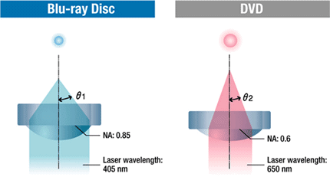
The NA is expressed by nsinθ (n is the refraction index, which takes a value of 1 in air). The larger the NA, the greater the θ value (θ1 > θ2) and the smaller the laser beam spot.
Comparison of laser wavelengths and NA
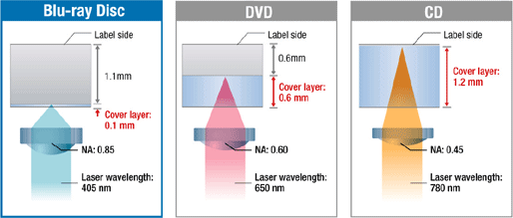
The NA of the Blu-ray lens is 0.85, as compared to 0.6 for DVD. Although the beam spot size can be reduced by increasing the NA, it was no easy task to manufacture a lens with a large NA.
In conventional optical discs, the NA of the objective lens is small. Because of this, molded single-lenses are used. It is possible to increase the NA by using a multi-lens system, similar to the lens systems used in microscopes. However, this makes the lens larger and heavier, making it unsuitable for use with optical discs.
It takes advanced manufacturing techniques, and especially molding technologies, to reduce the NA of a single lens. Panasonic has developed improved manufacturing technologies that produce a Blu-ray objective lens with an NA of 0.85.
Why Is the Cover Layer Only 0.1-mm Thick?
The third key technology for achieving the large data storage capacity of the Blu-ray Disc is one for reducing the thickness of the disc's cover layer.The cover layer is provided to protect the recording layer of the disc from scratches and dust.
Let's take a look at the cross sections of the DVD and Blu-ray Discs.
Cross sections of DVD and Blu-ray Discs 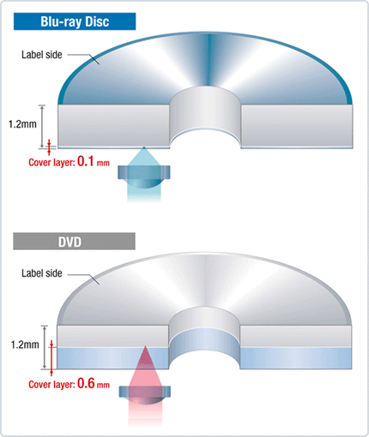
On the Blu-ray Disc, the distance between the disc surface and the signal recording surface (the thickness of the cover layer) is 0.1 mm, as compared to about 0.6 mm for the DVD disc.
Because optical discs are made of plastic, a certain amount of warping cannot be avoided. However, this warping changes the incident angle of the laser beam on the disc surface, which distorts the shape of the beam spot. This prevents stable data recording and playback. In the Blu-ray Disc, the NA of the lens is increased to reduce the size of the laser beam spot.
However, the larger the NA becomes, the greater the spot distortion becomes due to the warping of the disc. To solve this distortion problem, it was necessary to reduce the thickness of the cover layer.
Achieving a thin cover layer with uniform thickness at a low cost required the development of new disc manufacturing technologies. Panasonic successfully developed a method to produce discs with a 0.1-mm cover layer by using a resin spin coating process.
The new manufacturing method suppresses the effect of disc warping to achieve reliable recording and playback.
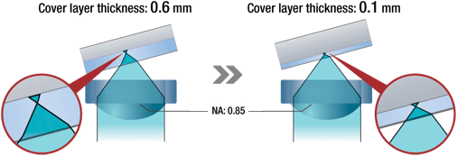
A cover layer that is 0.1 mm thick enables an objective lens with an NA of 0.85, to minimize spot distortion caused by disc warping.
The Blu-ray Disc has the following three basic optical specifications: a wavelength of 405 nm (nanometers), an objective lens numerical aperture (NA) of 0.85, and a transparent protective layer (cover layer) thickness of 0.1 mm.
Comparison of laser beam wavelengths,
NA and cover layer thicknesses
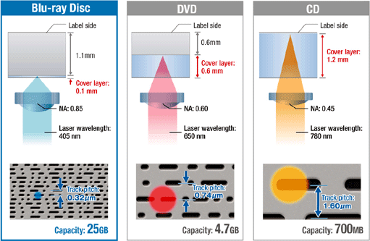
These are the ultimate requirements for producing a practical laser, optical pickup, and disc. Optical disc engineers combined their efforts to optimize these specifications, and created the Blu-ray format as a mainstream, high-density recording media for the years ahead.
Blu-ray is a next-generation disc format. The single-side, dual-layer disc structure is also an important factor for enabling the immense data storage capacity of 50 GB. Next, a Panasonic specialist in this field will describe this structure in detail.

Blu-ray Benefits

1. HD Image Quality Video
In addition to the MPEG-2 format used by DVD-Video, the BD-Video disc uses video codes, such as MPEG-4 AVC and VC-1, which deliver high image quality using high compression rates. The data transfer speed is 48 Mbps, which is about five times faster than DVD. A future plan also calls for a further increase in the data transfer speed. These technologies allow long-time playback of content with high-definition image quality.

2. High Quality Surround Sound
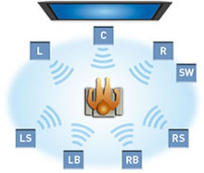
The BD-Video disc optionally supports next-generation surround sound formats like Dolby Digital Plus. Connecting a BD-Video player to an AV center using an HDMI* cable enables linear PCM multi-channel data transfer. This makes it possible to reproduce high-quality 7.1-channel surround sound with each channel offering DVD-Audio quality, delivering a surround sound experience that rivals the quality of the master audio source.
* HDMI Ver. 1.1 and newer.

3. The High storage Capacity
The BD-Video disc boasts a data storage capacity of 25GB* in a single layer and 50GB* in dual layer, because it uses the shorter wavelength blue-violet laser and a high-density objective lens to enable higher-density data reading. When a multi-layer system is adopted in the future, the storage capacity can increase to 100 GB* and even 200 GB*. One BD-Video disc can store a huge amount of data so users can enjoy many hours of high-definition content and high-quality surround sound that could not previously be provided by other media.
*1GB=1 Billion bytes. Useable capacity will be less.
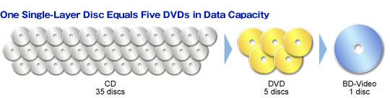
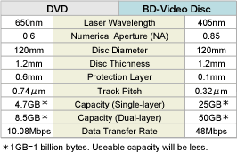
Structure of the BD-Video Disc
The Blu-ray Disc is an optical disc with the same dimensions as the DVD disc: 12 cm in diameter and 1.2 mm in thickness. By using a combination of the 405-nm-wavelength blue-violet laser, which is a shorter wavelength than the red laser used by DVD, and a high-density objective lens with a numerical aperture of 0.85, BD uses a laser beam spot that is only about 1/5 the size used by DVD. Thanks to these technologies, a single-layer BD-Video disc can store five times more data than a DVD disc.
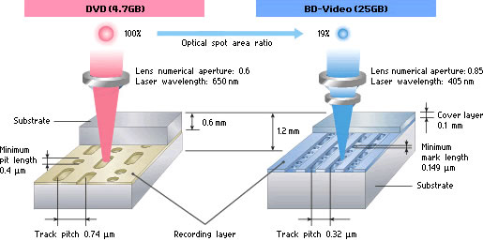

4. BD-J for Extensive Interactive Functions


Some BD-Video disc is equipped with an extended function based on Java™ technology, called BD-J, to provide various interactive features. For example, this can be used to program various operations, such as displaying a pop-up menu while playing a BD-Video disc, and activating a keyword search. With unlimited application possibilities, BD-J offers interactive enjoyment that is simply not possible with conventional AV software.

Others

1. What is Blu-ray?
Blu-ray is a new optical disc format with over five and a half times the storage capacity of a standard DVD (25 GB versus 4.5 GB). A dual-layer Blu-ray disc can hold up to 50 GB of information. With that increased storage, movie studios can finally provide movies on disc in high definition, offering 6x the resolution or image detail of DVD and up to 8 channels of lossless (better than CD quality) digital sound. The new format can also provide interactive features that go well above anything ever offered before.

2. Is Blu-ray different than HDTV
HDTV, or high definition television, is a new broadcasting format that offers widescreen, high resolution images offering 6x the resolution or image detail of DVD, with up to 5.1 channels of digital audio. Until now, the signals were only available through over the air transmissions (via an antenna), or through digital cable and satellite signals. You can not get HD signals from a standard video tape or DVD. An HDTV is a high resolution video display that is capable of receiving and displaying these HDTV broadcasts or images. Blu-ray is a complement to your HDTV. It’s a disc media format that has enough storage to include an entire movie, plus soundtracks and bonus materials, recorded in the high definition format. You can play Blu-ray discs back on your HDTV and see the same, if not better image and sound quality as you do from HDTV broadcasts.

3. What kind of TV do I need to enjoy Blu-ray?
You can play back Blu-ray movies on any TV with composite video or better inputs (not RF), but to get a worthwhile benefit from the format over DVD you’ll want to have a high-definition television, or HDTV, with a vertical resolution higher than 480p, and preferably higher than 720p. Most Blu-ray titles can deliver an image with a vertical resolution of 1080i or 1080p. The more horizontal resolution the TV can reproduce, up to 1920 lines or pixels, the better.

4. How are Blu-ray discs different than regular DVDs?
Blu-ray discs are the same size as DVD or CD, but use a blue* laser to store and read data as opposed to the red laser used in DVDs and CDs. The blue laser’s shorter wavelength, combined with a smaller aperture lens and a thinner cover layer on the disc makes it possible to create a smaller beam spot size capable of storing and reading much more, smaller information on the disc. A single-layer Blu-ray disc can hold 25 GB worth of data, compared to 4.5 on a standard DVD. A dual layer BD disc holds up to 50 GB. This translates into the ability to store a full 1080p HD image. This has a resolution consisting of 1920 by 1080 progressively scanned pixels, compared to standard DVD’s 720 by 480 pixels. In addition, Blu-ray has much wider bandwidth than DVD, delivering signals at speeds up to 48 Mbps, six times faster than DVD’s 8 Mbps, and nearly 2.5 times the data of an HDTV broadcast’s 19.2 Mbps. *technically, it’s violet, but who’s keeping track?

5. What kind of cable, connections do I need to have to make Blu-ray work?
You will need either a 3-wire analog component (typically labeled Y, Pr and Pb) or an HDMI digital video connection between the BD player and the TV. The HDMI connection is preferable. Not only will it provide better image quality, but it will pass along higher resolution audio and control information, as well. You may get limited up-conversion options with standard DVDs when using the component connection.

6. What does Profile 1.0, 1.1, 2.0 mean?
Blu-ray’s specifications for video are broken into three profiles, each with its own set of hardware and software requirements. Profile 1.0 gave hardware manufacturers a grace period to create players that were capable of Blu-ray video playback, but didn’t need to meet the final standard profile requirements. This grace period ended October 31, 2007. These players, while not able to take advantage of all of Blu-ray’s promised extra content, will provide full 1080p video playback.
Profile 1.1, also known as BonusView, makes certain requirements mandatory: picture-in-picture, secondary audio mixing, a minimum of 256MB of memory (built-in or removable), and the incorporation of a virtual file system. Players created and sold after October 31, 2007 are required to meet the Profile 1.1 specification, and therefore will take advantage of 1.1-enabled bonus materials on certain BD discs.
BD-Live (Profile 2.0) makes mandatory all parts of Profile 1.1, but increases the memory requirement to 1GB and adds the hardware requirement of a network connection. This specification enables the even-more interactive web-based bonus material found on discs that provide such content.

